Pre-Lesson Assessment Questions

How long can an ignition source lay dormant before starting a fire?

Are equipment fires preventable?

What can a fire extinguisher do?

When do fires start in the field?

When should you call for help when a fire starts?

What are four ignition sources that originate from mechanical equipment?

1.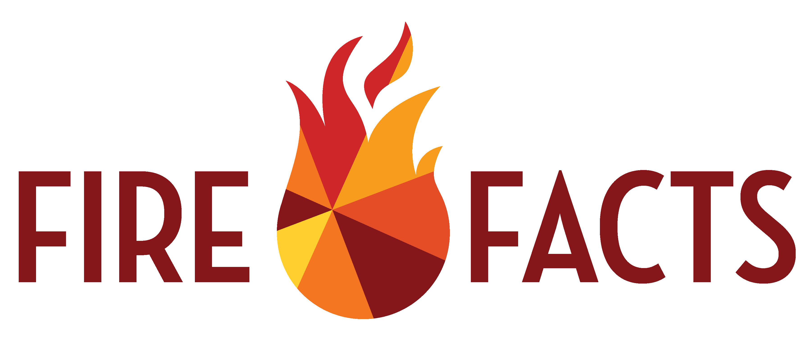 Friction - Sparks/Slag

Lesson 3: Equipment Fires

2. Conduction - Heat Transfer

3. Combustion - Flame

4. Electric - wiring shorts

How does understanding equipment operations prevent fire from starting?

Give some examples of ignition sources

What is a clear zone and how do you determine its size?

Ignition Source Distance x 4 = Clear Zone Diameter

How do you calculate the probability of ignition?

How do you determine risk?

How do you prevent equipment-caused fires?

How does proper maintenance prevent fires from starting?

Lesson 3: Equipment Fires

What are 3 items you need in a fire plan?

1. First actions

2. Who to call

3. What to communicate