Pre-Lesson Assessment Questions

What does it take to start a fire?

Where and why do wildfires start?

Is fire unpredictable and why or why not?

What does it take to stop a fire?

Why do I need to understand how a fire burns and moves?

What is necessary for a fire to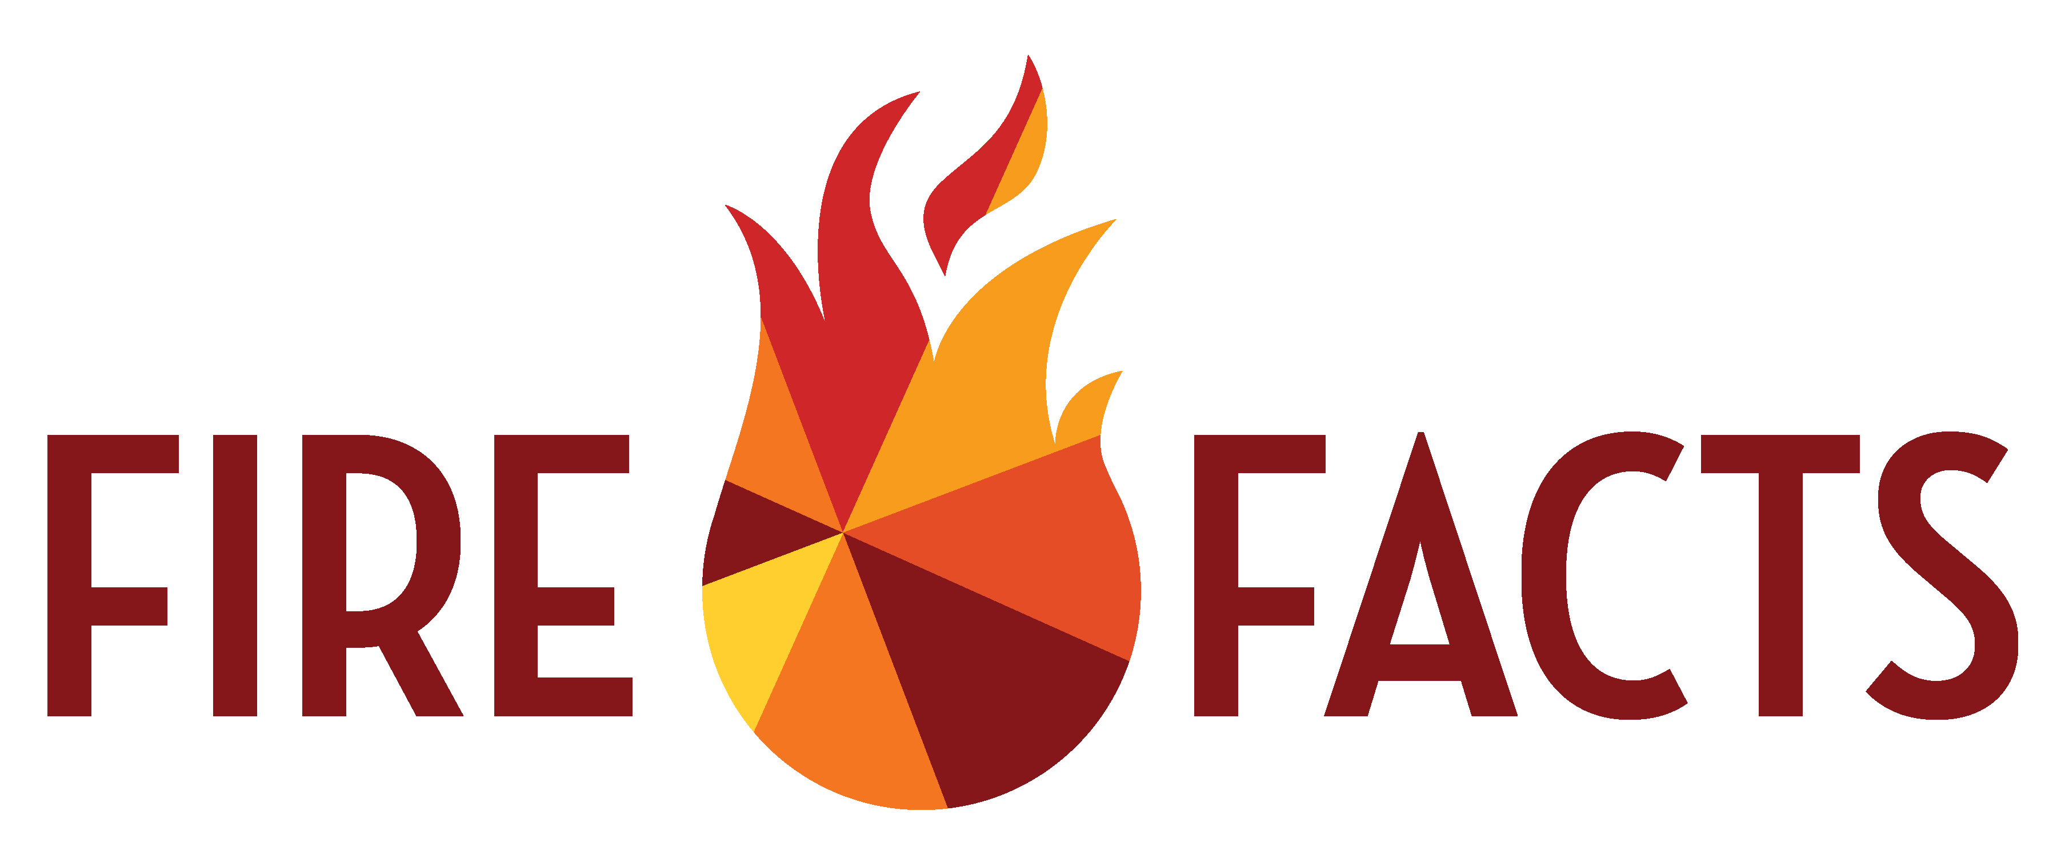 start?

Lesson 1: Fire Behavior

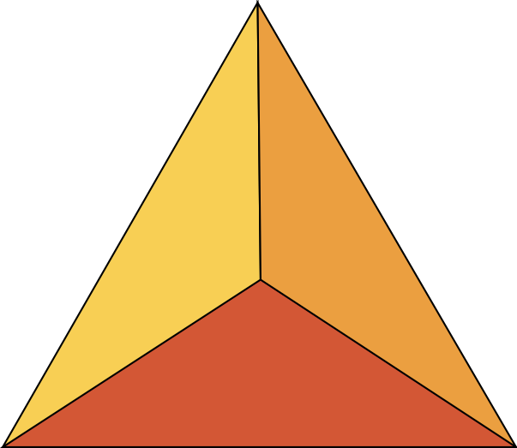

**3**

**1**

**2**

What three factors are required for fire to Burn ?

1. Heat

2. Fuel

3. Oxygen

What do you need to stop combustion?

What are 5 factors that effect fire combustion?

1. Type of fuel

2. Fuel moisture

3. Air movement

4. Fuel placement

5. Fuel temperature

What are the 3 fuel factors that influence fire behavior?

1. Air movement around fuels (compactness)

2. Fuel placement

3. Fuel temperature

What are 3 ways weather effects fire behavior?

1. Temperature

Lesson 1: Fire Behavior

2. Wind

3. Relative humidity

How does elevation effect fire?

How does aspect effect fire?

Why is it import to understand fire behavior?

1. Prevention

2. Safety

3. Planning