Pre-Lesson Assessment Questions

Are all fires bad?

Are all fires the same?

Why is fire scary?

Can fire be helpful/good?

What needs fire to survive?

Explain how fire effects environments & community differently?

What are the chemical and physical changes to fuel during a fire?

What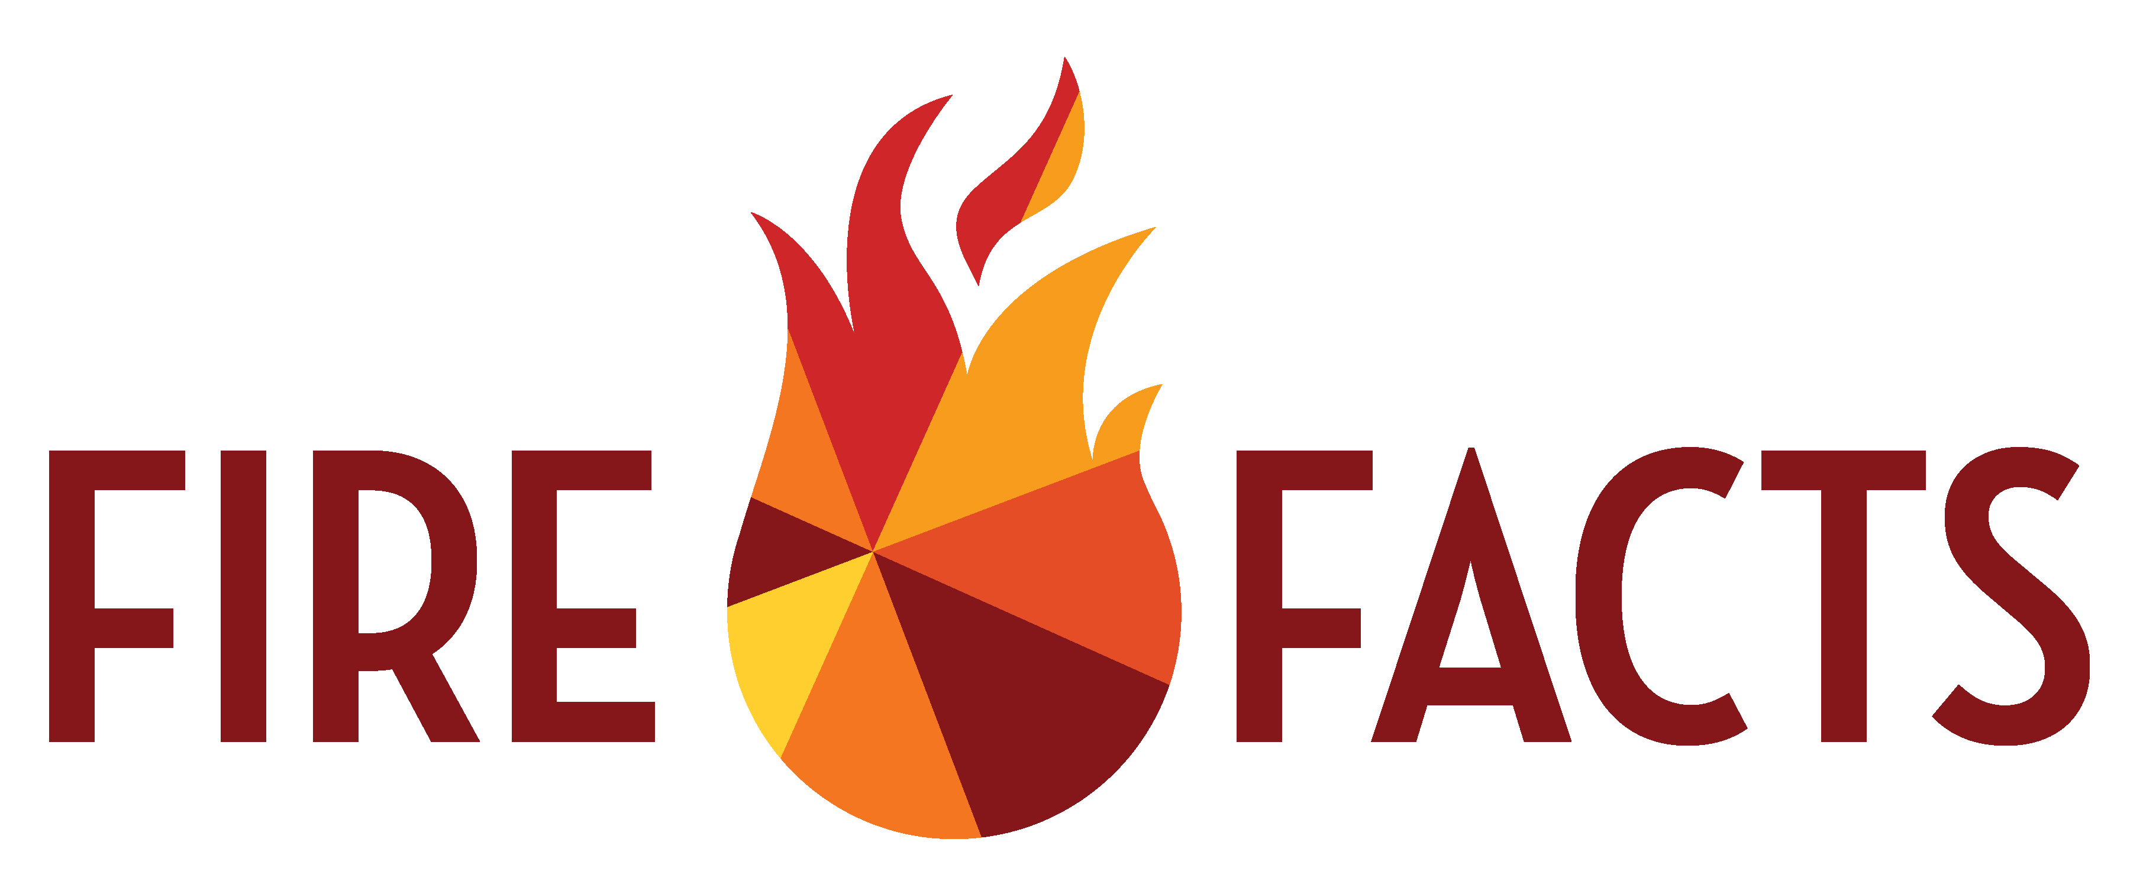 are three ways a fire changes an environment?

Lesson 2: Benefits of Fire

1. Cleans

2. Returns/recycles nutrients

3. Balances the ecosystem

What are the effects of extreme fire intensity on landscapes?

1. Reduces Water Absorption

2. Changes vegetation

3. Increases Erosion Potential

4. Air quality

5. Bakes the ground

What are the effects of low fire intensity on the landscapes?

1. Strengthens some species

2. Reduces large/intense fire effects by cleaning

3. Higher nutrients in vegetation

How does a fire clean an environment?

1. Reduces dead fuel

2. Reduces fuel load

3. Clears understory

4. Weed/invasives management

How does a fire renew an environment?

Lesson 2: Benefits of Fire

1. Promotes new vegetation growth

2. Reduces inhibiting materials

3. Fill in local answer

4. Fill in local answer

What are the benefits of low intensity fires?

1. Manageable

2. Easier to protect property

3. Fill in local answer

4. Fill in local answer

Explain how fire can improve the landscape in your area?