Pre-Lesson Assessment Questions

How far can a fire ember travel and start another fire?

Where and why do fires start on the farm/ranch?

What does it take to keep the items of value in your yard from catching or spreading fire?

How fast do fires spread?

Where d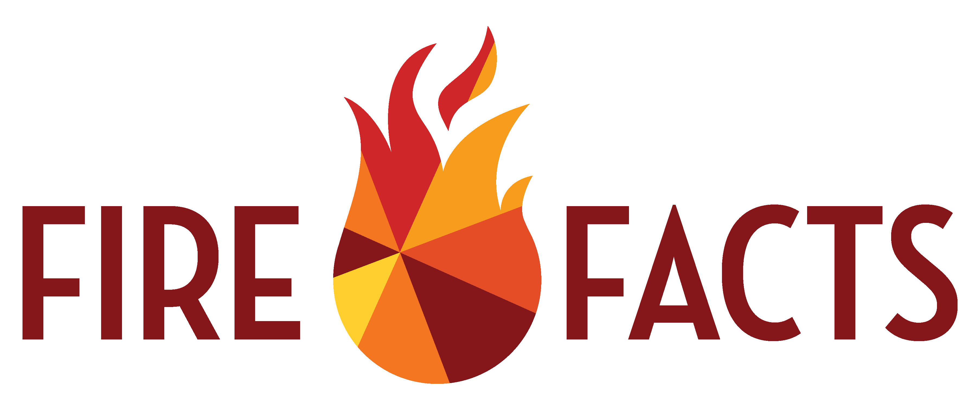o fires start in the farm yard?

Lesson 4: Wildfire &

Your Yard

1. Electrical

2. Conduction

3. Chemical

4. Combustion

5. Friction

What is fuel continuity?

Describe examples of continuity in your yard?

What are the two things your yard is made of? List examples of each.

1. Fuel

2. Fuel Breaks

How do you determine the size of a fuel break when no wind is present?

Source Flame Height x 4 = Fuel Break Size

What are the factors that affect the rate of fire spread?

1. Continuity

2. Wind Speed

3. Fuel Moisture

4. Temperature

How do you prevent fires in your yard?

Lesson 4: Wildfire &

Your Yard

How do you prevent fire spread in your yard?

What steps do you need to take to protect your yard?

1. Calculate fuel breaks

2. Place fuel breaks

3. Maintain fuel breaks

What are 3 items you need in a fire plan?

1. First actions

2. Who to call

3. What to communicate