Pre-Lesson Assessment Questions

What is the job of a firefighter?

Who are firefighters?

What can firefighters do?

When should you call for help when a fire starts?

What are two types of firefighters?

1. Paid

2. Volunteer

What are four different firefighting disciplines?

1. Structure

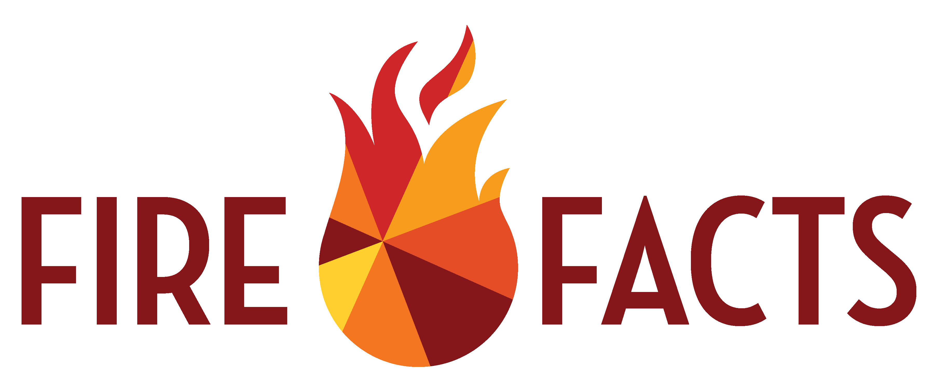2. Wildland

Lesson 5: Firefighters

3. Crash/Rescue

4. Industrial

Who do firefighters work for?

1. Local fire districts

2. Cities

3. State agencies

4. Tribal governments

5. Federal agencies

6. Non-profits

6. Contracted/Private

What determines the capabilities of firefighters?

1. Training

2. Experience

3. Resources

What are the limitations of firefighters?

1. Nature/Science

2. Number of firefighters

3. Resources

What firefighters support your area?

What are the capabilities of the firefighters in your area?

What are the resources of the firefighters in your area?

Lesson 5: Firefighters

When is the best time to meet firefighters in your area?

Why should you plan with firefighters in your area?

What should be in your plan with firefighters?

1. Lists of risk

2. Water sources

3. List of resources

4. To do list